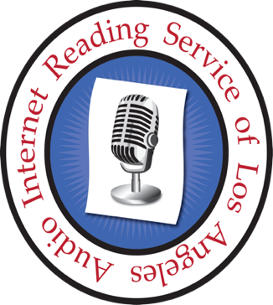**Audio Internet Reading Service of Los Angeles**

www.airsla.info

**Listening to Podcasts**

There are many easy options for listening to AIRSLA’s Second Vision and other AIRSLA podcasts. Listen on your smartphone, tablet, computer, Alexa or Echo, Google Home, or Victor Reader Stream. Read on for sample instructions; we use Second Vision as the example.

# Image of Alexa and Echo devices

**Alexa/Echo** – “Play the podcast called Second Vision.”

Image of Google home devices


**Google Home** - “OK, Google, play the podcast called Second Vision.”

## **Siri**

**Siri devices** – ‘Hey Siri, play Second Vision.”

## **Victor Reader Srream**

**Victor Reader Stream**- [click this link for instructions.](https://airsla.info/podcasts-listen/victor-stream/)